Ω-Lab Requirements
Overview
At each milestone, the following deliverables will be evaluated:
Deliverables
Project Plan 2
Project Presentation 2
Project Manual 3
Proof of Concepts 5
Concept List 5
Individual Assessment 9
Metacognitive Journal (Extra Credit) 11

You will be expected to create a physical circuit of your design as well as a Spice simulation file. You will be graded based on your progress and technical accomplishments. You will also need to provide individual self-assessments. There will only be one Project Manual which will be updated throughout the semester. There will also be a single ‘Proof of Concepts’ document which will also be updated throughout the semester. The purpose of this is to ensure feedback is incorporated into the report and you have the opportunity to correct your mistakes.
The Project Presentation and Proof of Concepts will have a fixed deadline set by the instructor. You will be able to choose the Project Manual deadline within a 3 week period: 1 week before through 1 week after the fixed Milestone deadline.

Project Plan
The Project Plan (see Project Plan) is a sheet that is meant to help you plan out your project, and it helps both you and the TA make sure that project scope is reasonable. The Plan asks you to outline what your project is, why you want to do it, what circuits you will need to build, and what goals you want to achieve in each Milestone period. This plan must be approved by a TA before you start your project.
A Project Plan is due at the start of each Milestone Period for those just starting Omega-Labs, and it is due during the Project Presentation for those already in Omega-Labs. The Project Plan is not graded directly, but may be graded indirectly during the Project Presentation under the Presentation Grade’s ‘Planning’ Category (see below).

Project Presentation
The Milestone presentation is an informal presentation to the TA and Professor to demonstrate the functionality of your circuit and discuss your progress. In this presentation, you should:
- Demonstrate functionality of circuit
- Explain circuit operation
- Discuss problems encountered and solutions
- Discuss user feedback obtained and how it was incorporated into the design
- Support design choices
- Discuss future plans
- Have an updated Project Plan for the next Milestone prepared for review
You can include anything else you deem necessary. The Milestone presentation is a good opportunity to get feedback and ask for advice. Plan for this to take ~5-10 minutes.
User Feedback
In the Milestone Presentation, you must discuss some user feedback you received on your project. User feedback simply means you had someone outside your group (which could be a TA, classmate, roommate, etc.) use your circuit and received input from them on how to improve it. You should show in your presentation that you have updated your design to incorporate this feedback.
Presentation Grade
During the Milestone Presentation, the TA and Professor will provide a grade for each of the following metrics:
Goals: Goals for the Milestone have been met.
Functionality: Circuit works as intended, or building blocks individually work and group explains why the overall design cannot work.
User Input: User feedback was incorporated.
Self-Analysis: Group can identify issues (technical and personal) and suggest solutions.
Planning: Group knows the next steps and have a plan to accomplish them.
You will be given a grade of 10, 8, 5, or 1 for each metric.
Examples:
Excellent (10): Group has met all of their goals established for the Milestone.The design accomplishes what it was intended to do, or building blocks are individually functional, and group explains why the design cannot work. Group sought out relevant user feedback from multiple people and revised their design based on the input. Group identified issue linking two building blocks and suggests what to try next to solve the issue. Group has filled out a revised project plan with adjusted project scope that is more manageable given their prior pace.
Good (8): Group has met most of their goals established for the Milestone. Design does not work, but individual building blocks work. User feedback was incorporated but had an insignificant impact on the design. Group can point out issues with circuit but doesn’t know how to debug or redesign to solve the problem. Project Plan has been revised.
Needs Improvement (5): Group has met some of their goals for the Milestone. Some of the building blocks work, and group can suggest why the other building blocks are not functional. User feedback was received but it is not translatable into any design improvements (e.g., “The user said the design was fine.”). Group struggles to discuss how building blocks are meant to translate into project goals. Project Plan for next Milestone does not have a manageable scope given the group’s previous work.
Poor (1): Group has not met most of their goals. Individual building blocks do not work. No user feedback. Group is unable to critically assess their failures. Project Plan for next Milestone does not have a manageable scope given the group’s previous work.

Project Manual
The Project Manual is not a traditional report. Most reports require discussion of the context of your project: Introduction, Discussion, Conclusion. This reflects what an academic journal paper on experimental results might include, but it isn’t realistic of what it required in most engineering jobs. Technical documentation like that seen in datasheets is more useful for engineers trying to succinctly communicate to each other how their design works and how to use it. This approach is meant to free you from spending time on long reports and instead let you focus on communicating only what is essential in an effective way. The context and most of the analysis and measurements have been moved to the presentation and Proof of Concepts page. If you feel a report is more suitable for your project, you can talk to the TA or Professor.
The Project Manual should include the following sections:
- Description
  - Complete schematic and block diagram
  - Description of the operation and intended application
- Operation and Design
  - Input and output of each building block as well as the circuit as a whole
  - Design equations (if someone were to redesign the circuit for different conditions, what equations would they use to do that; What are the equations relating the input and output of each building block?)
- Operating conditions
  - Describe situations in which the circuit does not work (What is the maximum voltage that can be applied to a building block?)
  - Describe the limitations of the project
- Applications and Integration
  - Describe possible applications of your circuit
  - Describe how the circuit may be modified for alternative applications
  - Discuss potential improvements to your circuit
An engineer reading the project manual should be able to use it to rebuild and redesign the circuit. It might be a good idea to have a friend read your report first and see if they understand how the circuit works. Refer to Example Project Manual for more details on what to include in your project manual.

Project Manual Grade
The TA will use the following metrics to grade your Project Manual:
Feedback: Feedback from previous Milestone has been incorporated.
Mathematical Analysis: Analysis supports design decisions and is correct.
Documentation: Documentation is clear and explains all components.
Application: Group critically assess actual circuit operation and considers real-world applications.
You will be given a grade of 10, 8, 5, or 1 for each metric.
Examples:
Excellent (10): All feedback from previous Milestone has been incorporated into design and reports. Mathematical analysis is present to support design decisions and the analysis is correct. Documentation sufficiently describes the operation of the circuit such that the reader could build or redesign the circuit. Many limitations of the project are described and potential solutions are suggested. Several applications for the circuit are outlined, and necessary modifications for those applications are described.
Good (8): Feedback from previous Milestone has been incorporated into design. The group makes educated guesses as to why the circuit does not work but is not certain and has no analysis or measurements to support these suggestions. Design decisions equations are shown, but component values seem to come from guesswork rather than the equations. Documentation describes all individual building blocks and their corresponding design equations. Some formatting errors are present, such as missing axes in plots. Hardware ‘bugs’ are described, but no explanation is provided as to what causes them. Applications are provided, but advice on how to modify circuit for specific application is lacking.
Needs Improvement (5): Feedback from previous Milestone has been partially incorporated. The group incorrectly guesses as to why the circuit does not work. Design equations are not entirely correct, and design decisions are from guesswork. Some key equations are missing. Key figures are missing and figures demonstrating circuit function are incorrect. Report blames equipment for shortcomings rather than providing an analysis based on circuit concepts. Provided applications are not relevant to circuit, and suggestions for circuit modification are incorrect.
Poor (1): Feedback has not been incorporated. The group does not understand why the building blocks do not work and cannot propose any approaches to determine the problem. Design decisions are not supported, and design equations are mostly incorrect. The documentation does not include all components of the circuit and results would not be reproducible from manual. Report is poorly formatted and difficult to read. No limitations are described, and given applications do not directly apply to the circuit.
The Project Manual will be graded on Google Drive and the TA will leave feedback for you. To receive a ‘10’ in the feedback grade, you should incorporate all feedback into your design and Manual by the next Milestone. The feedback may be related to report formatting or design aspects. The first Milestone will not have a feedback grade.

Proof of Concepts
You must submit a summary of your analysis on each of the concepts below as they apply to your project. For each Milestone, you must cover the concepts which correspond to the Units you are covering in class (see the Course Webpage or Switching Between Alpha and Omega Labs for an overview of when each unit and concept is covered). For example, by the Milestone 1 deadline, you must cover each of the concepts outlined below for Unit 1. For each concept, you should include:
- Header with concept name
- The name of the building block to which it corresponds
- A labelled circuit diagram
- A 1-2 sentence description of how you are applying the concept
- A mathematical analysis
- A simulation
- A measurement
- A brief discussion of the results
See the example entry. Keep in mind that these entries do not need to be long - in fact, keep them as brief as possible! You can apply multiple concepts to the same circuit. If a concept doesn’t appear to be applicable to your circuit, there are several options:
- Use a circuit from alpha labs to analyze.
- Ask a TA.
- Create a new circuit to compare to your circuit. For example, if your project has a second order filter, but not a first order filter, you may design a first order filter and compare its performance to the second order filter.
In the latter case, you will still be able to opt out of the final if you design a secondary circuit related to but not in your design. You will fix and update your concepts report over the semester. It will be reviewed at each milestone. In order to opt out of the final, your project must include each of the following concepts in the analysis of your circuit.
Pay attention to specific questions listed below that we require you to answer.

Concept List
Unit 1
Ohm’s Law
Polarity
One of: KVL, KCL, Nodal Analysis, or Mesh Analysis
- In Discussion section, compare and contrast each of these methods of analysis. Discuss when you might use one over the other.
Circuit Reduction of Parallel and Series Resistors
Voltage Divider
Equivalent Sources
Superposition
Thevenin or Norton Circuit
Operational Amplifier as a Comparator
Operational Amplifier as an Amplifier
Unit 2
Equivalent Impedance
First-Order Circuit (RC or RL)
You can analyze one circuit for each of the following analysis requirements, or multiple circuits with only some of the analysis requirements applied. Make clear in your Proof of Concepts what analysis you are doing.
Must analyze:
- Step Response with:
  - Differential equations: provide time-domain function f(t) where f is the variable of interest
  - Laplace (s-Domain): provide s-domain circuit, s-domain function F(s), time-domain function f(t)
- Time constant
Second-Order Circuit with Voltage Source and Second-Order Circuit with Current Source
You must apply this analysis to a second-order circuit with a voltage source and also to one with a current source (two sets of analysis). You can analyze one circuit for each of the following analysis requirements, or multiple circuits with only some of the analysis requirements applied. Make clear in your Proof of Concepts what analysis you are doing.
Must analyze:
- Step Response for Overdamped, underdamped, and critically damped cases:
  - Differential equations: provide time-domain function f(t) where f is the variable of interest
  - Laplace (s-Domain): provide s-domain circuit, s-domain function F(s), time-domain function f(t)
  - Provide resonant frequency and damping ratio for each case.
Unit 3
Phasors
Complex Power
Transformers
- Ideal Transformer
- Real Transformer
Unit 4
First-Order Filter
Must analyze:
- Transfer function
- Bode plot
- Poles and Zeroes
- Resonant frequency
- Rolloff
Second-Order Filter
Must analyze:
- Transfer function
- Bode plot
- Poles and Zeroes
- Resonant frequency
- Rolloff

Example of Proof of Concepts
You will have an entry like the following one for each of the required concepts.
Voltage Divider
Building Block: Light Sensor circuit. R2 represents the resistance of the light sensor with 100 lux incident.
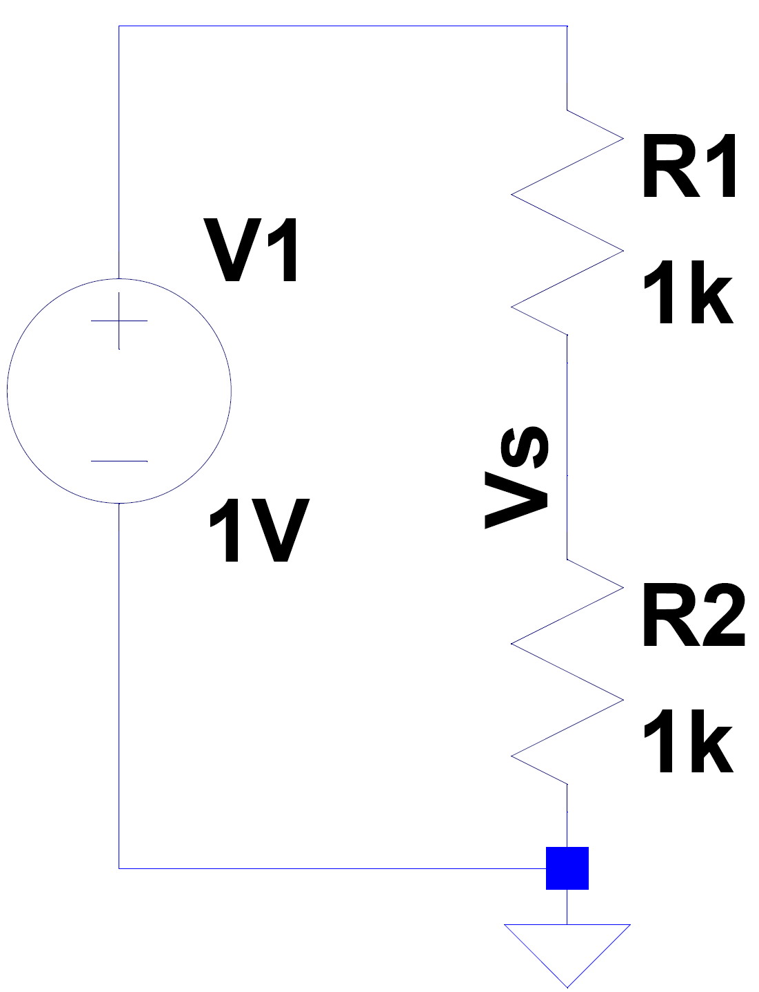
Clearly label all nodes you will reference
Analysis:
Describe clearly how you are applying the concept
We use the voltage divider equation to find the voltage output of the light sensor, Vs, when 100 lux of light is incident on the sensor.
$$V_{s}=\frac{R2}{R1+R2}V1=\frac{1}{2}V$$
Simulation:
We performed a DC operating point analysis on the circuit.
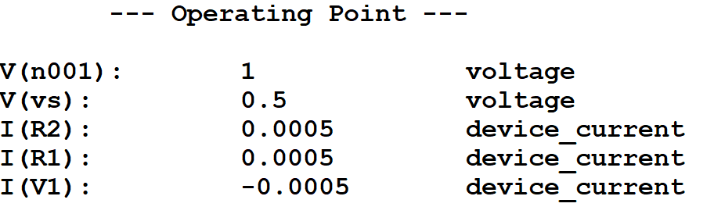
Measurement:
Picture of measurement from Waveforms should be placed in this section
Remember to clearly show all axes in a measurement plot.
We measured the output of the light sensor circuit with approximately 100 lux incident.
Discussion:
The measurement value differs slightly because the light source varied in intensity.

Individual Assessment
The Individual Assessment can be found in the document Individual Assessment. The purpose of the Individual Assessment is (1) see how much each group member is contributing, (2) make sure our assessment of you lines up with your self-assessment, and (3) understand your role in the group. We encourage you to fill it out over the semester and reflect on your contributions to and role in the group. The Individual Assessment will be submitted to gradescope on the Milestone Deadline. The assessment will be used as a Grade Modifier. It may increase or decrease your personal grade, but likely your grade will remain the same as the group grade.
If you ever feel like you’re taking on all of the group work or if you feel like you have trouble contributing to the group, please talk to the TA or Professor as soon as possible.
Building Blocks
This is a list of potential building blocks for your project. This list is not comprehensive, and you can get new blocks approved by a TA or Professor in your Project Plan. You can also argue that some blocks can be placed in other Milestone sections. Each building block can only satisfy a single unit requirement. Each Milestone must include: An Input stage, 2 new Primary stage blocks for the corresponding Milestone, and an Output stage. The Input and Output stages can remain the same throughout the semester. See Choosing a Project for more details on how to design a project.
Input Stage
Choose at least 1 input
Sensor
IR LED
Antennae
Photodetector
Microphone
Temperature Sensor
Light Sensor
Gas Sensor
…
User Interface
Buttons
Switches
Potentiometer
Power Generator
Primary Stage
Choose 2 for each Milestone

Milestone 1
Digital to Analog Converter (R-2R Ladder)
Inverting Amplifier
Non-Inverting Amplifier
Summer
Difference
Comparator
Wheatstone Bridge
Milestone 2
Analog-to-Digital Converter (Rectifier and First-Order Filter)
Monostable Multivibrator (Timed Pulse Generator)
Astable Multivibrator (Square Wave Generator)
Differentiator
Integrator
Analog Multiplier
First-Order Passive Filter
Second-Order Passive Filter
Phase Shifter
Milestone 3
Transformer
Analog Multiplier
First-Order Filter
First-Order Passive Filter
Second-Order Passive Filter
First-Order Active Filter
Second-Order Active Filter
Output Stage
Choose at least 1 output
Solenoids
LED
Display
Motor
Buzzer
Antennae
…

Metacognitive Journal (Extra Credit)
Document how and why you are doing what you are doing, using tools outlined in the associated document! Extra credit value and placement will be decided toward the end of the course, though likely it will be used toward the final exam.
(See Circuits_Metacognition and Reflections)

