|  |  |  |
| --- | --- | --- |
| **IV Characteristics – Time domain** | | |
| **Resistors** – | **Inductors** – | **Capacitors** – |
| **Continuity conditions** | | |
|  |  |  |

|  |  |  |  |
| --- | --- | --- | --- |
| **IV Characteristics – Laplace domain** | | | |
|  |  | |  |
| **Resistors** – | **Inductors** – | | **Capacitors** – |
| ***Impedance, Z [Ω], properties have the same characteristics as resistance***  ***Impedances in series add,***  ***Impedances in parallel have an inverse relationship,*** | | | |
| Initial Value Theorem | | Final Value Theorem | |

|  |  |  |  |
| --- | --- | --- | --- |
| First order circuits  Differential equation:  , with solution  represents a source function or nth derivative of the source function, with appropriate coefficients  represents the homogeneous/transient part of the solution  For first order circuits, the homogeneous solution always takes the form  represents the particular/forced part of the solution.  The particular solution is always the same type of function as the source.  τ is the time constant  For RC circuits,  For RL circuits, | | | |
| Second order circuits  Differential equation:  , with solution  s-domain  represents the homogeneous/transient part of the solution  The form of the homogeneous solution depends on the damping  represents the particular/forced part of the solution.  The particular solution is always the same type of function as the source.  represents a source function or nth derivative of the source function  represents the Laplace transform of the function f(t) | | | |
| **Overdamped**  **(α > ωo)** |  | |  |
|  | |  |
| **Critically Damped**  **(α = ωo)** |  | | from the differential equation |
|  | |  |
| **Underdamped**  **(α < ωo)** |  | | from the differential equation |
|  | |  |
| RLC series circuit | | RLC parallel circuit | | |

***Partial Fraction Expansion***

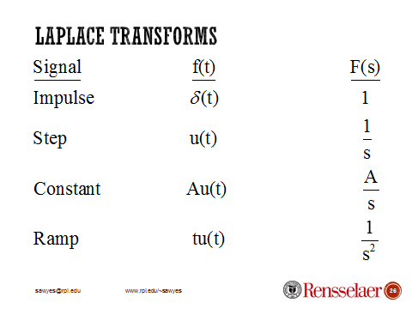***Simple Real Poles:***

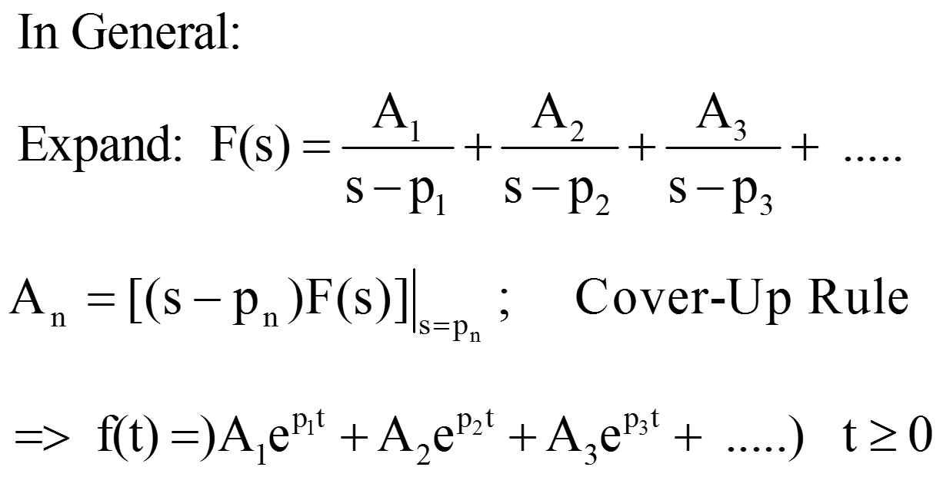

***Real, Equal Poles – Double Pole:***

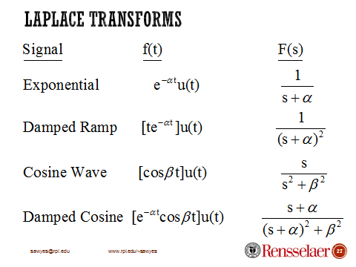******

***Complex Conjugate Poles***

