|  |  |  |  |
| --- | --- | --- | --- |
| **Bode Plots** | | | |
|  | | | Decade – a change in frequency by one order of magnitude, for example  100 rad/s → 1000 rad/s  104 Hz → 105 Hz  dB – decibel  dB = 20 log |F(jω)|  Note the argument of the logarithm is a magnitude expression  A change of 20dB corresponds to a of |F(jω)| by one order of magnitude |
| **Bode plot magnitude approximations** | | | |
|  | Slope +20dB/decade | | |
|  | Slope -20dB/decade | | |
|  | ‘Flat’, dB = 20log|K| | | |
| **Sketching Bode plot magnitudes (real poles and zeros)** | | | |
| Crossing an n-pole: Slope **changes** by -20*n dB/decade  Crossing an n-zero: Slope **changes** by +20*n dB/decade | | **‘n’** indicates the number of poles or zeros  ‘Crossing’ rules apply when going from a lower frequency to a higher frequency | |
| **Sketching Bode plot phases (real poles and zeros)** | | | |
| Crossing an n-pole: Phase **changes** by  Crossing an n-zero: Phase **changes** by | | Phase changes are ‘spread out’ over two decades, one decade on either side of the pole or zero | |
| **Corrections for Bode plot magnitudes (real poles and zeros)** | | | |
| At an n-pole: The ‘real’ dB valule is -3n dB ‘below’ the asymtote  At an n-zero: The ‘real’ dB valule is +3n dB ‘above’ the asymtote | | The asymptote is the straight line approximation of the Bode plots  ‘Far away’ from poles and zeros, the asymptotes are an accurate representation of the Bode plot | |

|  |  |
| --- | --- |
| **Second Order Circuits** | |
| Damping ratio, **,** a metric of the damping  α is the attenuation constant  ωo is the resonant frequency | δ > 1, overdamped  δ = 1, critically damped  δ < 1, underdamped |
| Lowpass/Highpass filters  Overdamped and critically damped cases, the Bode plots follow the procedure on the previous page  Underdamped cases, use the critically damped approximation, add a ‘correction’ of  at the resonant frequency, ωo  Bandpass filters  Overdamped, the Bode plots follow the procedure on the previous page  Critically damped and underdamped cases  At the resonant frequency, the magnitude Bode plot is 0dB  The vertex where the stopbands meet is  *Note: The above discussion is for second order circuits only. If there is a gain stage, the Bode plot moves ‘up’ or ‘down’ and the dB value of the gain determines the reference for adding corrections/stopband vertices* | |
| Cascaded Filters – Magnitude Bode Plots | |
| H(s) = H1(s)H2(s)H3(s) (three stages) →  dB = 20log|H1(jω)H2( jω)H3( jω)| = 20log|H1(jω)| + 20log|H2(jω)| + 20log|H3(jω)|  angle = | |
|  | |
|  | |
|  | |

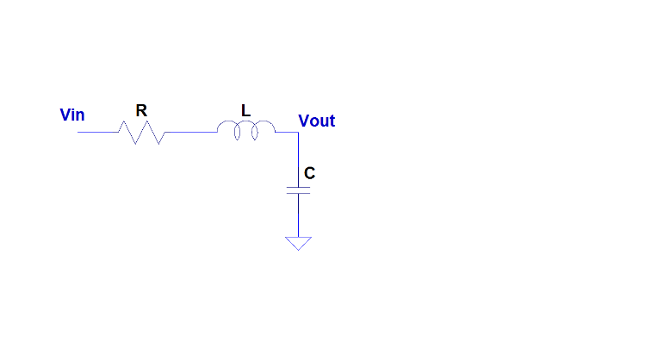

***Second order filters***

Filter name





pole/zero ID

2 poles

Low pass filter



2 zeros at zero

High pass filter



2 poles



1 zero at zero

Bandpass filter

2 poles

Bandstop filter



