Project Plan
Contents
Choosing a Project 1
Example Projects 1
How to Choose a Project 1
Project Plan Assignment 3
Project Plan Example 5

This is a guideline to help you and your TA determine if your project is well-defined and feasible. You must fill this out anytime you want to change your project. See the example Project Plan below for more details on what is expected.

Choosing a Project

Example Projects
Some potential projects which could span all 3 Milestones and have a reasonable scope are:
- Simple reaction-time based video game
- IR or RF communication
- Synthesizer
- Phase-Locked Loop
- Lock-In Amplifier
- Simple Robotics (motor control)
- Sensor systems for data acquisition (e.g., ultrasonic range finder)
- Remote control circuits
- Solar Panel sunlight tracker

How to Choose a Project
Generally, each unit covers concepts that enable you to use certain types of building blocks. Unit 1 concepts will teach you to deal with sensors (which are like often like variable resistors), comparing DC values to ‘make decisions’, and amplifying voltage values. Thus, for Milestone 1, a good starting point is to have an input such buttons or a sensor feeding into a comparison or math stage which generates a signal for the output stage.
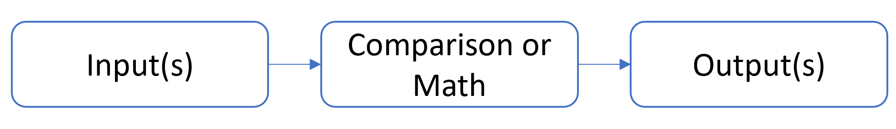
Unit 2 covers timing circuits and transient waveforms. You will be able to generate various shapes of waveforms (square wave, triangle wave, sinusoid) and perform additional math operations (differentiation, integration). By Milestone 2, you could start implementing communication systems or AC to DC circuits. You might be able to construct some simple frequency filters as well.
Unit 3 covers analysis of AC circuits, AC power, and transformers. This Unit provides you with the skills to choose a power source for your circuit. It also allows you to analyze circuits that perform operations on sinusoidal signals such as mixers (multipliers) and phase shifters.
Unit 4 covers filters. There are many different types of filters: first-order, second-order, passive, active, etc. These circuits can ‘select’ certain frequencies, which makes them good in applications that need to filter out noise from a sensor or activate a particular output for a given frequency.
Because Milestone 3 is heavily focused on filters, make sure your project will be able to include a filter. You may not get your Project Plan signed off it does not seem like a filter can be included in your project.

Project Plan Assignment
Project Description
Include a block diagram

What is the purpose of the project?
Who is the user? Why did you choose this project?

Milestones
Outline your goals and deadlines for at least the upcoming Milestone. Try to fill out as much as you can for the other Milestones so the TA can give you advice.
Milestone 1 (Date: )

Milestone 2 (Date: )

Milestone 3 (Date: )

Reason for update (if applicable)

Parts List
List an expected number of parts you will need that are not in your circuits kit. List the cost of parts you want to purchase.

What potential issues do you foresee with this design?

What skills and concepts do you need to learn to do this?

What is your plan if this design does not work?

Who will be your end-user?

Checklist:
A TA must check each of these items to pass the plan. Be prepared to answer each of these questions with justification.
☐ Can the project be completed in the given time?
☐ Do the milestones provide a reasonable pace for the project?
☐ Does the project align well with the learning objectives of the course?
☐ Does the project use at least two building blocks from each Milestone?
☐ Does the block diagram match the desired functionality?
☐ Is the circuit size and cost reasonable?
☐ Can at least 4 Milestone Concepts apply to the design?

Team Signatures
______________________________
______________________________
______________________________
TA Signature
______________________________

Project Plan Example
This is a guideline to help you and your TA determine if your project is well-defined and feasible. You must fill this out anytime you want to change your project and at the beginning of each Milestone period. You only need to cover your plan for the upcoming Milestone but try to plan as far as possible. This will help the TA and Professor give you feedback on how to adjust your project to be more manageable and give advice on how to implement certain parts.
Project Description
Include a block diagram. Label blocks with their corresponding unit.
We will design a Remote Control (RC) car using infrared (IR) signals for communication. The first Milestone will focus on remote communication. We will create a circuit to receive an IR signal and turn on a light (car’s headlights) from that signal.
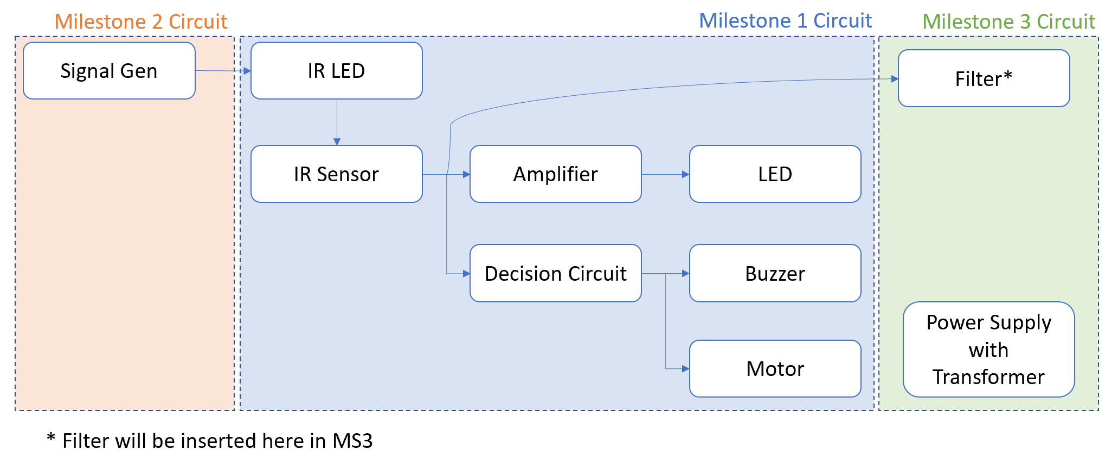
What is the purpose of the project?
Who is the user? Why did you choose this project?
The members of the group will be the user. Each of us would like to install remote communication circuits in our rooms for various purposes.
Milestones
Outline your goals and deadlines for at least the upcoming Milestone. Try to fill out as much as you can for the other Milestones so the TA can give you advice.
Milestone 1 (Date: )
- Research IR communication circuits
- Construct IR sensor circuit and determine voltage output for given IR signal
- Design Amplifier to convert IR Sensor output to the amplitude required by the LED.
Milestone 2 (Date: )
- Design Signal generator circuit to create square wave to send to IR LED
- Use passive filters for decision circuit
- Add Buzzer to circuit
- Choose appropriate power supply
Milestone 3 (Date: )
- Replace passive filters with active filters
- Add motors to circuit
- Add power supply to circuit
Reason for Milestone Plan update (if applicable)

Parts List
List an expected number of parts you will need that are not in your circuits kit. List the cost of parts you want to purchase.
For Milestone 1, we will need an IR LED, and IR photodetector, and Op Amp, and an LED. All of these parts are in our parts kit.
What potential issues do you foresee with this design?
The IR communication range will be limited, so the user will have to be fairly close to the car.
What skills and concepts do you need to learn to do this?
We will need to:
- Read about IR receivers and transmitters
- Learn about sensor circuits
- Learn about amplifier circuits
What is your plan if this design does not work?
If this design does not work, we will try to implement another project after Milestone 1. We are also interested in Lock-in Amplifiers where the IR components could also be used.
Who will be your end-user?
Our end-user will be our roommates and friends. We will ask them to play with our circuit and ask them how they would like it to function.

Checklist:
A TA must check each of these items to pass the plan. Be prepared to answer each of these questions with justification.
☐ Can the project be completed in the given time?
☐ Do the milestones provide a reasonable pace for the project?
☐ Does the project align well with the learning objectives of the course?
☐ Does the project use at least two building blocks from each Milestone?
☐ Does the block diagram match the desired functionality?
☐ Is the circuit size and cost reasonable?
☐ Can at least 4 Milestone Concepts apply to the design?

Team Signatures
______________________________
______________________________
______________________________
TA Signature
______________________________

