Project Manual
  - Group Members Names
  - Google drive link to LTSpice .asc simulation file
Delete all text in red before submitting.

Description
Complete schematic and block diagram
Schematic should be easy to read and all important parts (input and output, components that are frequently mentioned in text) should be labeled. The functionality of the block diagram should match that of the circuit schematic.
High-level description of the operation and intended application
Describe what your circuit does at a high-level – that is, describe in layman terms what problem you are trying to solve and how your circuit solves it. Describe the high-level operation of the building blocks in this description.
Description of related pre-existing applications
This can be separate from or embedded within the high-level description. You should demonstrate that you’ve done some research on your problem/application. It should be apparent that this research helped you formulate your design in some way.

Operation and Design

Input Block
Schematic
Labeled schematic of input block.
Design Equation
If possible, write the equation relating the input and output of the building block. OR you can place an input/output plot from a datasheet or a diagram describing the operation. Make sure to reference all plots someone else made!
Input/Output Plot
This can be an input/output plot from the datasheet or on you measured or simulated directly. For example, for an LDR, it might be a plot of sensor resistance vs input light intensity.
If you have more than 1 input block, you only need to describe 1 of them here.

MS1 Building Block 1
For EACH building block section, include:
Schematic
Labeled schematic of building block in isolation – that means not connected to your overall circuit.
Design Equation
Symbolic equation(s) relating the input and output of the building block. All variables must be defined either by labeling them in the schematic or defining them in-text. You do NOT need to show derivations of these equations.
(There are certain building blocks such as the Astable Multivibrator which don’t have an input. In these cases, use the governing equation for operation.)
Discussion of Component Choices
Discuss the particular component values you chose and why. For example, “We chose a resistor value of 1kOhm to ensure the reference voltage was 0.5V.” See also example Project Manual document.
Input/Output Plot
Plot of input vs output of building block and relating in some way to the design equation. Can be obtained by experimental measurement of physical circuit or simulation. Make sure all axes are labeled and it is clear what circuit variable you are measuring.

MS1 Building Block 2
Place holder for building block, same instructions as Building Block 1…

MSX Building Block x
If you have more than two primary building blocks in one milestone, you only need to describe 2 of them. Why? Because it makes grading easier. You will, however, need to describe their operation in Integration and Optimization.
Since the Project Manual will be updated at each milestone, you will keep the prior two building block section and continue to add new building block sections as needed here. Make sure to use the header structure “MSX Building Block x” where ‘X’ is the milestone number (2 or 3) and ‘x’ is the building block number (1 or 2).

Output Block
Same instructions as Input Block section.

Integration and Optimization
In this section you should describe the low-level operation of the circuit. Your discussion should be in terms of voltages, currents, frequencies, etc. You should start with describing the input and step through each building block to explain how it is transformed into the output. You should include the following discussion in the process:
- Explain how you designed each building block so they could be connected together (support design choices).
- Reference the building block design equations to explain how each building block was designed and how they work together.
- Discuss any issues you had in getting building blocks to work together.
- Plot the overall input and output of the integrated circuit and any other measurements that would be helpful in explaining operation.

Operating Conditions
Describe limitations of the circuit including situations where it does not work
You must describe the limitations of your circuit in a way that demonstrates you have researched your application, actually tried using your circuit, and deeply understand the operation of your circuit. You should list at least 2 limitations per Milestone, and at least 1 of these must clearly be related to electrical characteristics of the circuit and demonstrate an understanding of circuits concepts. For example, you might discuss the frequency range of your microphone or how environmental noise might affect your circuit and its operation in the relevant application.
You SHOULD NOT say obvious thing such as ‘the circuit cannot be used in water.’ You SHOULD NOT discuss things such as the voltage ratings of your op amp if this rating has no real effect on using your circuit in the given application.
You CAN discuss situations where the circuit does not operate but don’t fully understand why. You must propose some guess as to why it doesn’t work. For example, “Sometimes if the circuit is used outside for a long time, it ceases to output proper sensor readings. We believe this may be due to components getting too hot.”
You should write about a paragraph per limitation. You can include figures to help discuss the limitation.
Describe any tradeoffs present in the design
Describe at least 1 tradeoff per Milestone present in the circuit. A tradeoff in circuits occurs when two desirable features conflict with one another. For example, we could increase the distance of a laser by increasing the current through it, but this would increase power consumption and shorten the lifetime of our battery.
Describe how the circuit could be improved
Discuss 1-2 ways the current circuit could be improved even if they are not achievable due to time and cost restraints.

References
If you use information from any external source such as datasheets, provide a citation and citation number here. Remember to reference the citation number in the body of the report. You should use IEEE citation format (read here for more info). Word can automatically create and manage citations for you!

Appendix
If you have large images or lengthy calculations, place them here.

Other Things to Consider…
- Label all figures and tables and reference any figure or table in the body of your report (see the example report below)!
- Word has an equation editor you can access by pressing Alt+’=’. Google drive has an equation editor through Insert > Equation. These editors have lots of nice short cuts, like:
  - Special Characters: \alpha turns into $α$ (applicable to other Greek letters and special characters)
  - Subscript: A_0 turns into $A_{0}$
  - Superscript: A^0 turns into $A^{0}$
  - Fraction: A/(B+C) turns into $\frac{A}{B+C}$
  - And more…
- Make sure your LTSpice schematics are neat and legible. You can draw shapes and lines in LTSpice by navigating to Edit > Draw. You can print a schematic to a pdf by printing the file to PDF.
- Use net labels to declutter your LTSpice schematics.
- Your plots can be from LTSpice or measurements
- Please, keep the document short! More does not mean better. Use tables, equations, and plots to concisely explain your circuit. Don’t show derivations in the body of the Manual, and don’t do calculations in the text of a paragraph.

Project Manual Example: RC Car
This document provides an example of what is expected in a Project Manual. It is not a complete report, and it is only meant to provide an idea of what information is expected, how in depth you need to go, and how your report should be formatted. Page number recommendations are a guide not a requirement. Use your own judgement as to how much you need to write to explain your design. Whenever you see ‘...’ it means more writing is expected than what is provided in the example.

Description
(~1-2pgs, not including block diagram and schematic)
The Description is a high-level overview of what your project is and how it works. Detailed equations and analysis should generally be reserved for the Operation of Building Blocks section. You should provide your Block Diagram and Schematic and ensure they are clear and easy to read. Explain operation of the whole circuit and how the input becomes the output through the building blocks.
This project implements a remote controller and remote control (RC) car. The communication between the controller and the car is implemented with IR emitters and detectors. Commands are encoded in different frequencies. These commands include forward, left, right, and horn. Filters are used to determine which code is being transmitted and activate the corresponding output.
Acronyms should be introduced in parentheses after the word is used the first time as with ‘remote control’ above.
Tables should be labelled as Table #: Caption. Tables should appear in the order they are referenced in the text.
Table I: IR Frequencies and their corresponding command.
Frequency | Function
100Hz | Left
707Hz | Forward
5kHz | Right
10kHz | Horn

The full block diagram for the whole project is shown in Figure 1. There are two separate circuits: the remote and the car control. The remote translates button presses into the corresponding command frequency. The car circuit receives the remote signal and uses filters to activate the corresponding command circuitry. In this Milestone, only the circuitry for the buzzer is implemented: IR sensor, bandpass (BP) filter, Sine-Pulse Width Modulation (PWM) signal converter, and Buzzer.
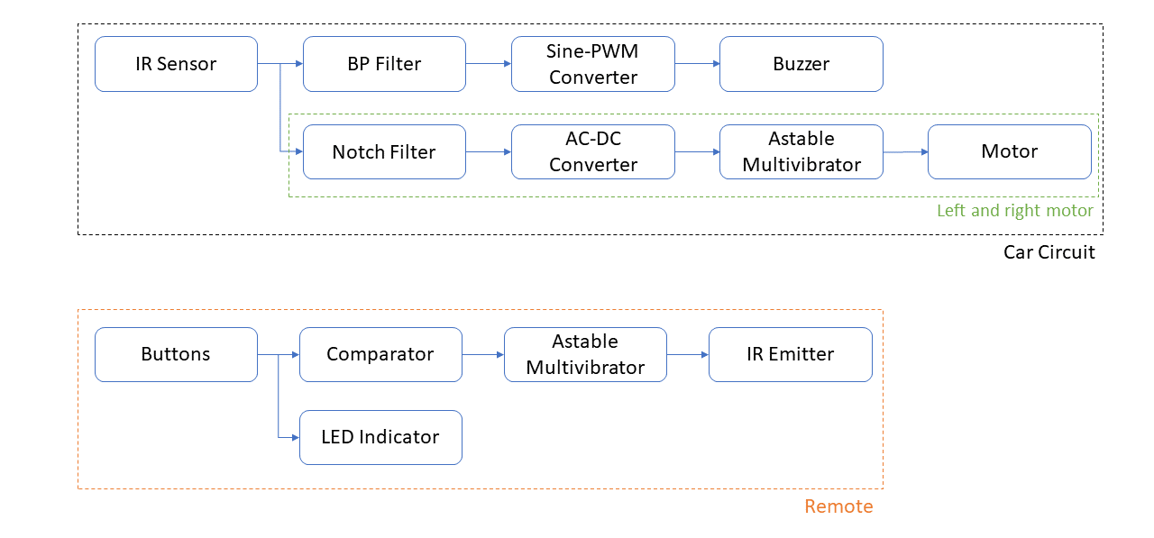
Figure 1: Block Diagram for project. Note that the Left and Right Motor circuitry is only shown once; two motor circuits exist: one for the left motor and one for the right.
Figures should be labelled as Figure #: Caption. Figures should be appear in the order they are referenced in the text. In Word, you can use References > Cross-Reference to insert an in-text citation of the figure label. Word will automatically update the referenced Figure number if it changes.
Figure 2: Schematic of Horn circuit.
Your schematic should be LARGE and CLEARLY LABELLED. Label any nodes you need to reference in text.
The circuit operates as follows. The IR sensors receives a sinusoidal IR signal and converts this into a sinusoidal voltage of the same frequency. The BP filter allows only signals very close to 10kHz through, so only the 10kHz command will activate the remainder of the circuit. The 10kHz sinusoidal signal will be converted to a 10kHz square wave. This will be sent directly to the buzzer which will produce a 10kHz frequency.

Operation and Design
(~2pg per building block including figures and equations)
This section should provide a detailed analysis of circuit operation, design choices, and circuit equations. You should have a section for each building block.

IR Sensor
Input stages should include information from datasheets. For example, for an Infrared (IR) sensor, I might talk about what kind of light sensor it is (resistive, photodiode, or phototransistor), and what its range of output will be for a given input.
…

Bandpass Filter
Building block sections should provide: a labelled schematic, a description of the purpose of the building block in the overall circuit, the equation relating the input to the output, and use of equations to support design decisions.
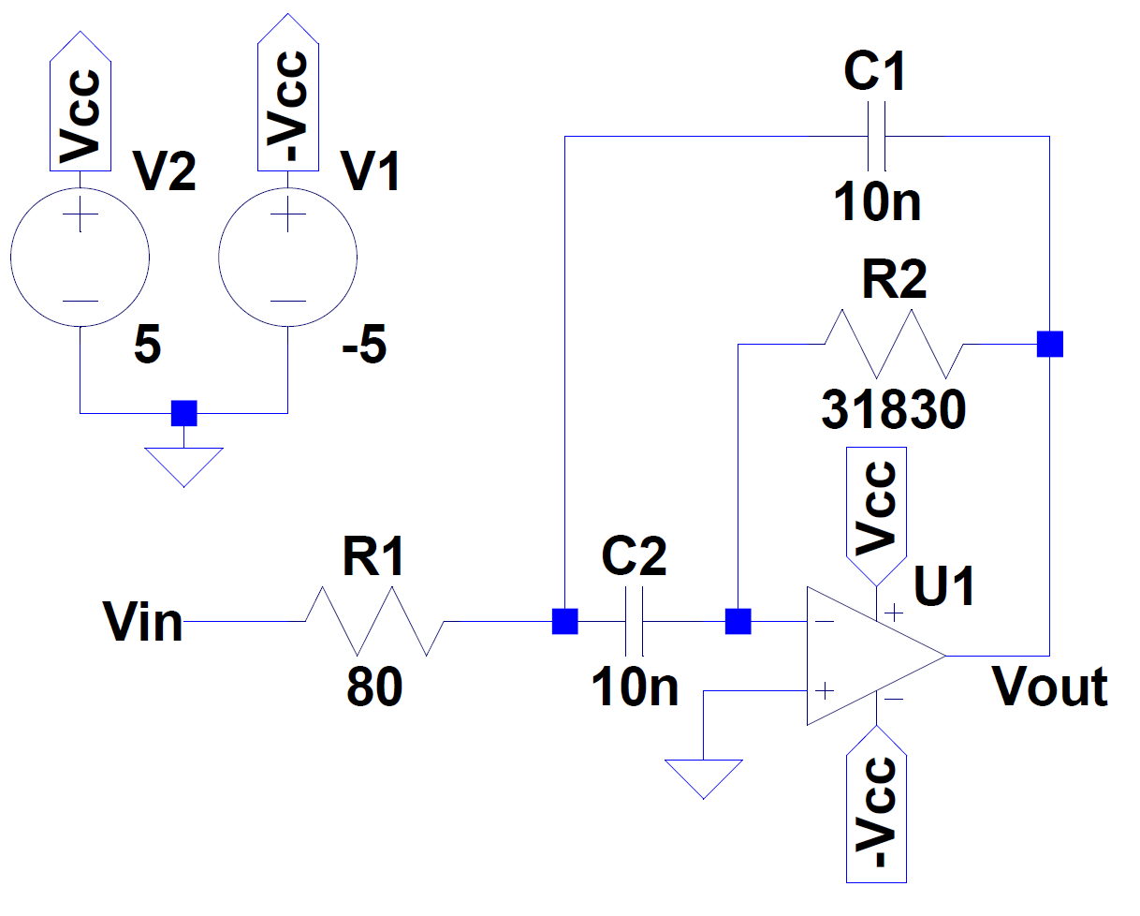
Figure 3: Second-order bandpass filter, ω₀=10kHz, ζ=0.05.
The IR signal for sounding the car horn (buzzer) is encoded as a 10kHz signal. To filter this specific frequency, a second-order bandpass filter as shown in Figure 1 is used. This filter is chosen because (1) it is an active filter, and (2) it is easy design and build compared to an RLC filter - that is any capacitor value can be chosen and the resistors can be calculated to satisfy the design specifications. Since a range of resistors is readily available, it is easier to find the design components than if the design required a specific inductor or capacitor.
The transfer function for this circuit is:
$$\begin{aligned}T\left(s\right)=\frac{V_{out}\left(s\right)}{V_{in}\left(s\right)}=-\frac{R_{2}C_{2}s}{R_{1}R_{2}C_{1}C_{2}s^{2}+\left(R_{1}C_{1}+R_{1}C_{2}\right)s+1} \#\left(1\right)\end{aligned}$$
Equations should be labelled with numbers in the format shown above. You can use the Word Equation Editor (Alt+’=’) to easily format and label your equations.
This yield the design equations:
$$\begin{aligned}\sqrt{R_{1}R_{2}C_{1}C_{2}}=\frac{1}{ω_{0}} \#\left(2\right)\end{aligned}$$
$$\begin{aligned}\sqrt{\frac{R_{1}C_{1}}{R_{2}C_{2}}}+\sqrt{\frac{R_{1}C_{2}}{R_{2}C_{1}}}=2ζ \#\left(3\right)\end{aligned}$$
In Figure 1, C₁=C₂, and the design equations become:
$$\begin{aligned}\sqrt{R_{1}R_{2}}C=\frac{1}{ω_{0}} \#\left(4\right) \end{aligned}$$
$$\frac{R_{1}}{R_{2}}=ζ^{2} \#(5)$$
The design requires f₀=10kHz with a sufficiently steep roll off such that other signals are filtered out. Thus, ζ=0.05 is chosen. A capacitance of C=10nF is selected, and from Eqn. (4) and (5) R₂=31830Ω and R₁=80Ω. The simulated Bode plot is shown in Figure 5.
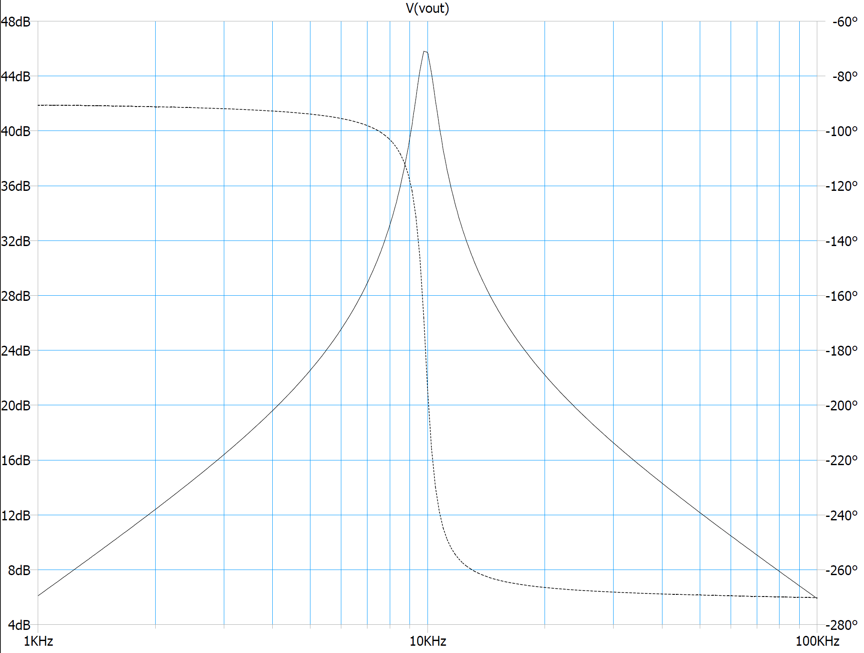
Figure 4: Bode plot of bandpass filter.

Sine-PWM Converter
…

Buzzer
Output stages should include information from datasheets such as their operating conditions (e.g., what current or voltage they operate at).
…

Integration and Optimization
(~2-5pg) This section should discuss how the building blocks work together at a circuits level (in the Description section, you should describe overall operation at a high-level). You should describe what each stage is doing, any design choices you had to make to get stages to work together properly, discuss any issues you had (or have) in getting the stages to work together, and provide plots to show how the circuit works.
The first stage of our circuit is the IR sensor, which produces an AC voltage, V_{ph}. We use a narrow bandpass filter to only allow incoming frequencies of V_{ph} to pass through to the next stage. To connect these stages together, we must ensure that the BPF’s input impedance is large enough to not affect V_{ph}. We do this by choosing R and C values for the BPF such that the input current is small compared to the sensor current. Figure 5 shows the output of the IR sensor and the resulting output of the BPF.

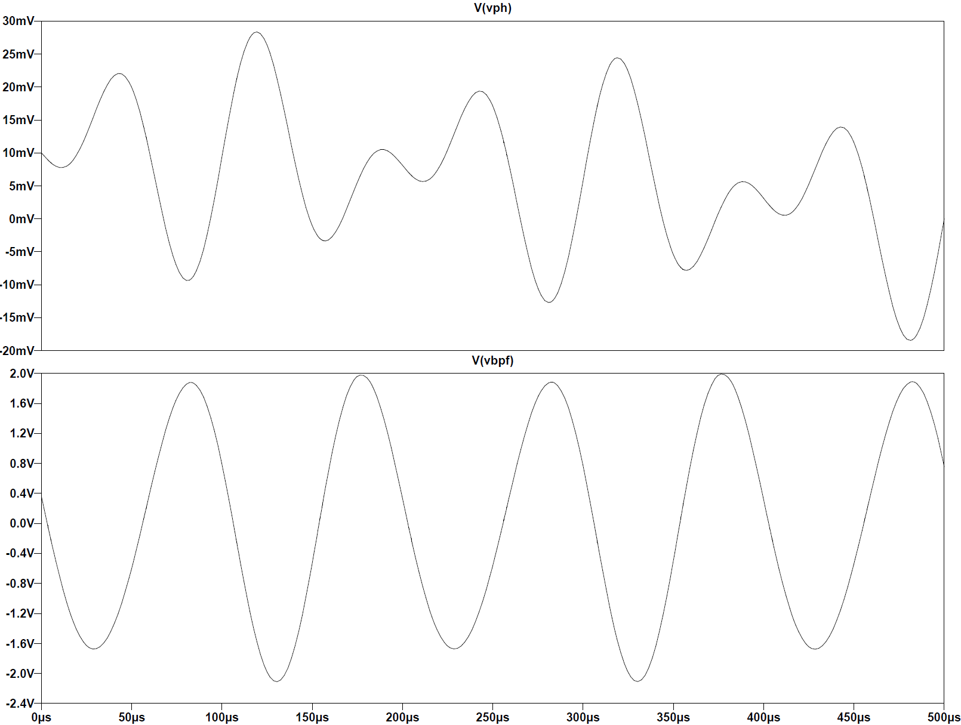
Figure 5: (top) Output of IR Sensor/Input to BPF; (bottom) Output of BPF
…
Figure 6 shows an example input and output of the overall circuit. The input (Vin) is measured at the sensor output, and the output (Vout) is measured at the buzzer. The input is a sum of a 500Hz, 10kHz, and 15kHz signal each of 10mV amplitude, which is representative of the output amplitude from the IR sensor. The output shows the 10kHz square wave to be applied to the buzzer.
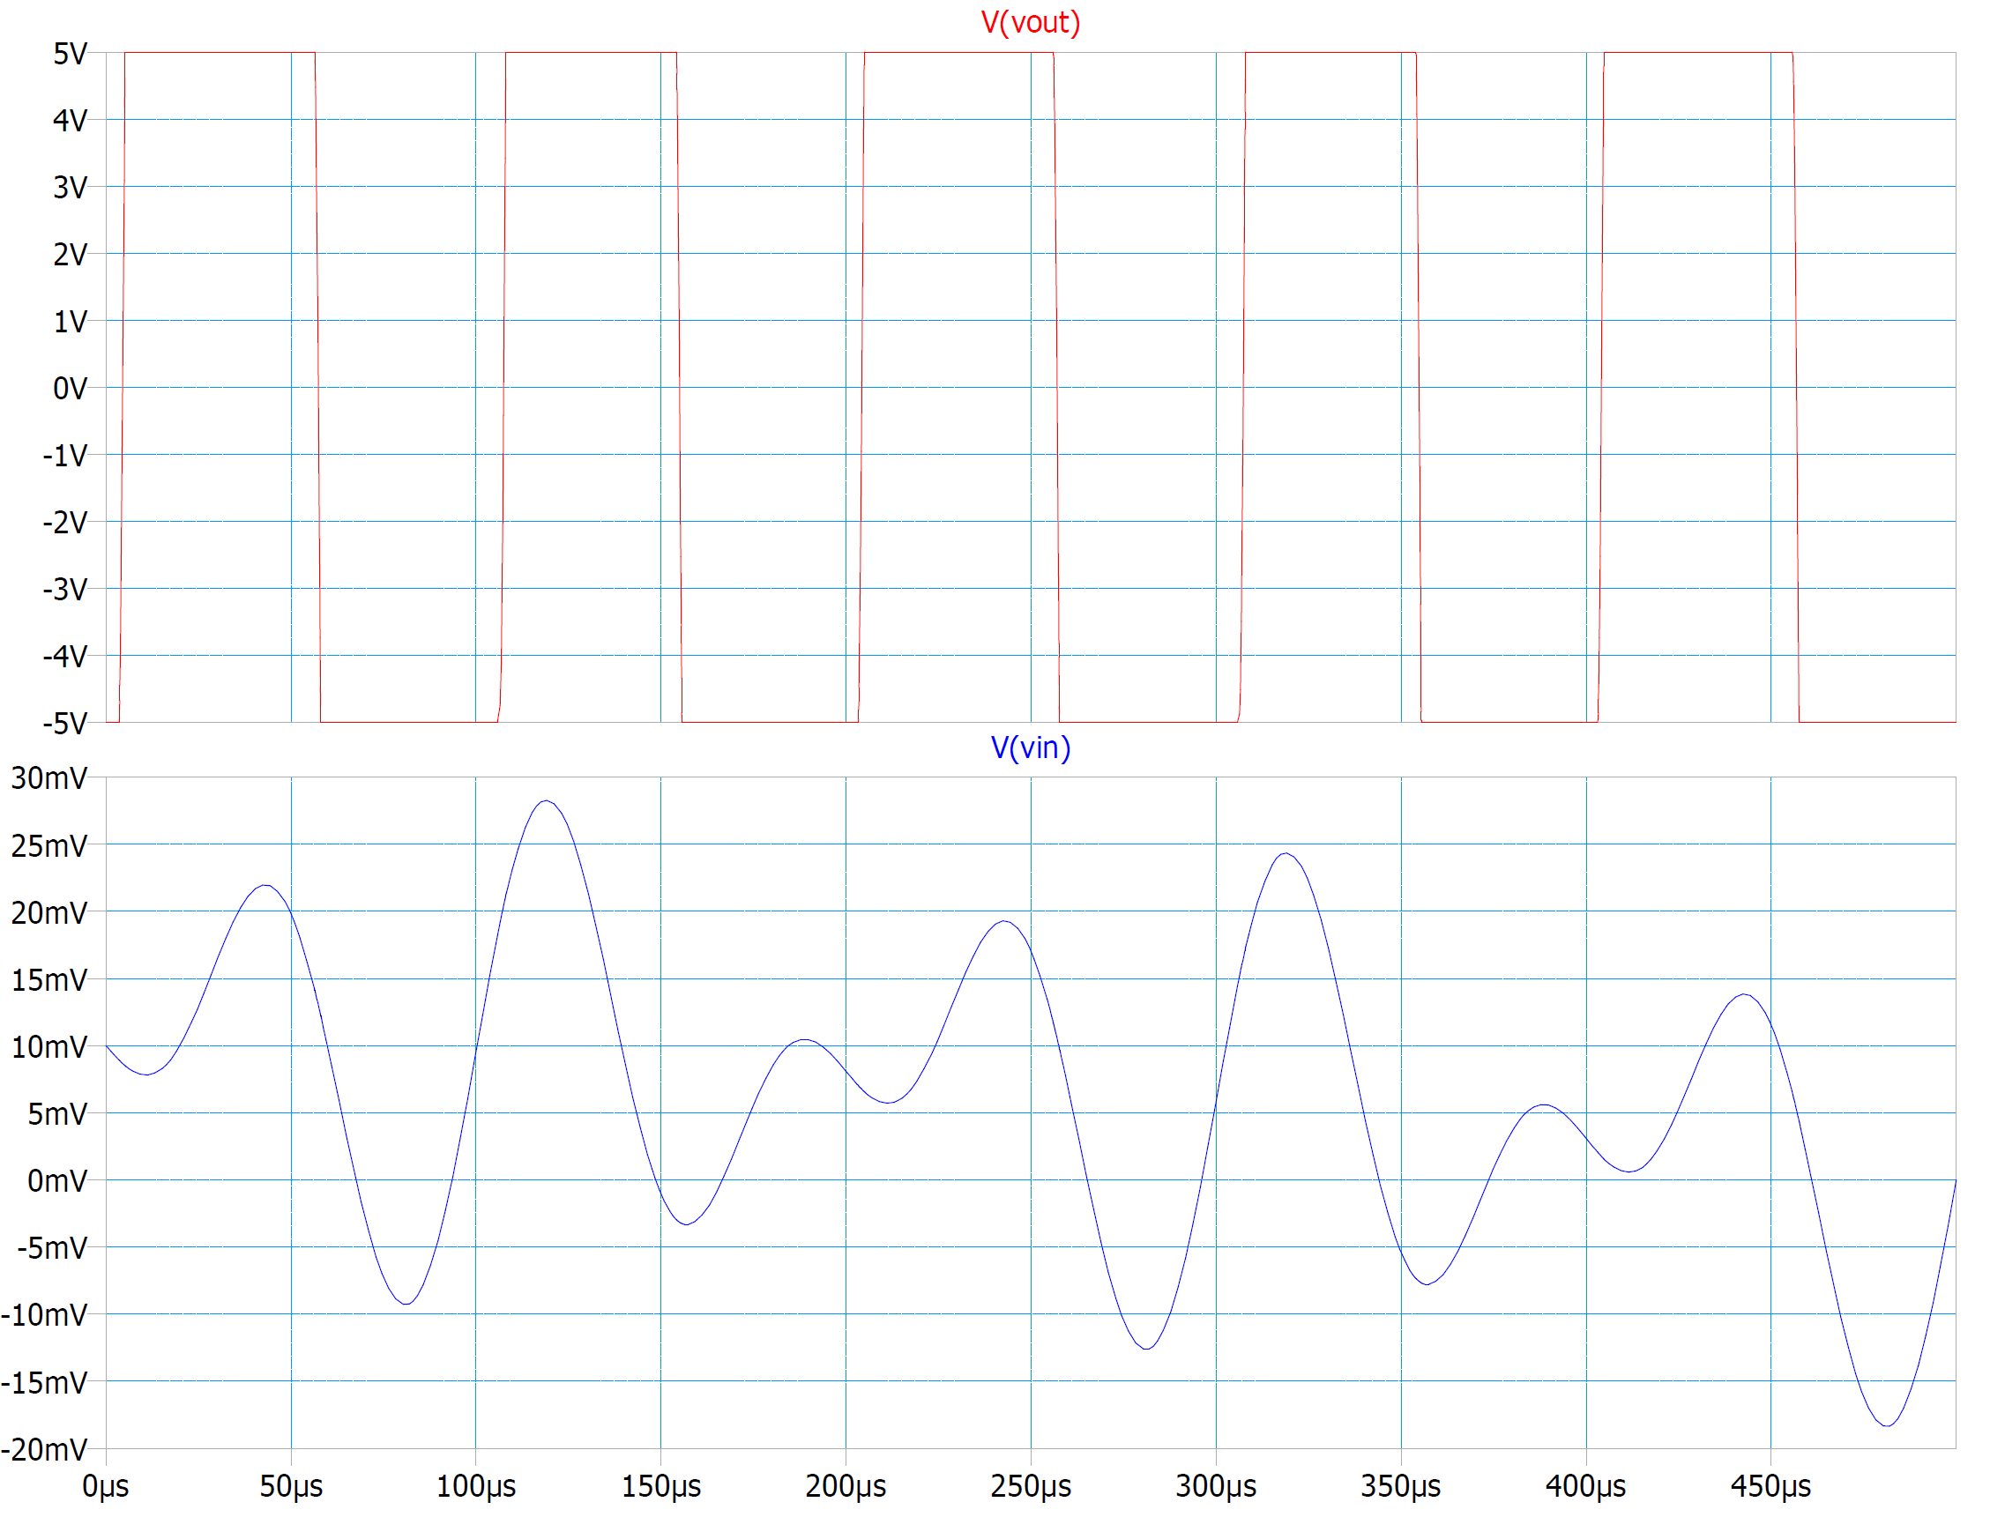
Figure 6: Example input and output.
…

Operating Conditions
(~1pg, the length of this section as well as the next section depends on what your project is and how far into the project you are. It does not need to be long, but it needs to demonstrate that you have spent some time thinking critically about how your circuit operates, its purpose, and its user.)
This section should describe how the circuit actually functions as you have observed, and situations under which it does not work. This might be operating voltage (is there a maximum or minimum voltage for the circuit to operate properly?), environmental conditions, or hardware ‘bugs’. Describe the limitations of your circuit, explain where these limitations come from, and propose possible solutions (even if you can’t implement them during the course).
The car can only operate in a radius of 15ft due to the IR signal being fairly weak. Furthermore, physical objects obstruct the signal from reaching the target. The operating range of the car is reduced to about 10ft outside in daylight due to light interference. A possible solution to this issue is to use a parabolic reflecting dish with an IR reflective coating to capture diffuse signals on the receiving end.
…

