Ω

The Omega Lab

Contents
Welcome 3
Overview 3
How Do Omega Labs Work? 3
Switching Between Alpha and Omega Labs 4
Are Omega Labs Right for You? 4
Grading 5
Deadlines and Deliverables 7
Lab Requirements 9
What to do in a Lab Session 9
Project Plan 9
Presentation 10
Project Manual 11
Proof of Concepts 12
Concept List (Proof of Concepts) 12
Building Blocks (Project Manual) 15

Welcome

Overview
Omega-labs are a design-based alternative to the traditional Alpha-labs, which are procedure-based. In most classes, labs are a set of instructions that you follow and report on with an academic journal style paper. But this isn’t what a real-world engineering job is like; most engineers need to come up with their own design and write user manuals and datasheets.
In Omega-Labs, you will have the freedom to design your own circuit based on what you have learned in the course. The requirements of the reports and evaluations of projects will be based on what is generally expected in a job.
Omega-Labs emphasize personal growth, learning from failure, planning, and iterative design. You will not be graded only on the overall functionality of the project. Instead, your grade will be based partially on your ability to meet your goals and incorporate feedback into your project and partially on the functionality of individual building blocks of the circuit and your ability to analyze them.

How Do Omega Labs Work?
Omega Labs are broken into 3 Milestones, each of which corresponds to a set of concepts. During each Milestone, you will be expected to design a circuit that contains at least 1 circuit building block for MS1 and at least 2 circuit building blocks for MS2 and MS3 from the corresponding course material, and that you will apply the course concepts to analyze your circuit. A building block might be a voltage divider, an amplifier, or a filter. A list of building blocks will be shown later in this document.
In addition to these building blocks, you can also include additional circuits not covered in this course such as digital IC’s, mechanical components, microcontrollers and more. If you don’t know any of the building blocks, you can still do omega-labs!
In fact, that’s where we expect you to start. We expect that your project will evolve throughout the semester as you learn more concepts and building blocks. We will be there to guide you through the process of project planning and making design decisions.
Deadlines for Omega-Labs are broken into 3 Milestones.

At each milestone you must provide:
- Updated Project Plan
- 5-Minute Informal Presentation
- Omega Lab Individual Check-In
  - 1-3 Minute Video
  - Gradescope online questionnaire
- Project Manual
- Proof of Concepts (PoC)
- LTSpice Circuit Simulation
- Physical Circuit

Each of these will be explained further in the next sections.

Switching Between Alpha and Omega Labs
You don’t have to do Omega-Labs for the entire semester, in fact, you can go in and out of Omega-labs. Because both Alpha- and Omega-labs are based on the Course Concepts, it’s easy to apply some concepts in your Omega-lab design and use alpha labs to ‘fill-out’ the others as needed. This can mean doing Omega-Labs for only part of the semester. For example, you may do Alpha-Labs for the first Milestones, and Omega-Labs for Milestones 2 and 3. You can also do multiple small design projects instead of one big design project.

Are Omega Labs Right for You?
Unlike Alpha Labs, Omega Labs are not consistent, straightforward, and predictable in terms of difficulty and time. Omega-Labs are potentially unpredictable and require you to be more involved. However, Omega-Labs provide many things Alpha-Labs do not: the freedom to build whatever you want and the chance to practice what engineers really do: design. To decide which Lab is best for you, think about your time constraints for the rest of the semester and what classes you’re taking. Consider too that you could use your Omega-Lab project in another class or independent study. Think about how you learn best as well - do you need a structured assignment to learn, or do you do best by diving in and creatively applying the concepts?

Grading
You will not be graded only on the overall functionality of your entire circuit; If your whole circuit does not work, you may not lose any points from your lab grade. However, each individual building block must be functional on its own. One purpose of this design lab is to give you a safe space to try new things and fail. By not grading you on the functionality of the whole circuit, we hope to encourage exploration and to allow you to experience and learn from failed designs.
You will be graded based on your progress (have you met your goals, incorporated feedback, and do you know what needs to be done next), your technical accomplishments (functionality of building blocks, design decisions, communication in manual), and your Proof of Concepts. The grade distribution is meant to distribute the grade evenly between mathematical analysis, design, and progress. In addition, 40% of your lab grade depends on the completion of 1 Proof of Skills Check-in and 3 separate Omega Lab Individual Check-Ins that highlight your individual contribution to your labs. The Omega Lab Check-Ins will also include a peer evaluation of your group members.
All of the Proof of Concepts together is worth 33% of the total lab grade.
TO OPT OUT OF THE FINAL, YOU MUST:
- Complete Milestone 3
- Physically connect/integrate the Milestone 3 Circuit with either the Milestone 1 or 2 Circuit
- Get at least an 80% on each and every assignment for Milestone 3 and one other Milestone
- Complete all Individual Check-Ins with significant contributions to the lab group
- Complete >90% of ALL Skills for your Proof of Skills (i.e. 71/79 total points)
If you don’t meet the grade requirement, there will be an opportunity at the end of the semester to optimize your circuit and earn some points back.

Documentation Grade (6% of overall grade)
Assignment | Grade Percent
Proof of Concepts | 33.3%
Project Manual | 33.3%
Presentation | 33.3%
Project Plan | 1%

Individual Check-In Grade (6% of overall grade)
Assignment | Grade Percent
1-3 minute video | 50%
Online Individual Check-In Gradescope Submission | 50%

Proof of Skills (3% of overall grade)

Deadlines and Deliverables
Omega-Labs are divided into 3 Milestones. A major part of the project is due at the end of each milestone, and minor sections are due halfway between each milestone. The dates listed are the on-time due dates. Please see Gradescope for late due dates.
Due Dates | Assignment
1/31 | Proof of Skills (pre-lab assessment)
1/31 | Proof of Skills Check-In (pre-lab check-in)
2/6 (Tuesday before Lab!) | Project Plan MS1
2/21 | Milestone 1 Checkoff:  Individual Check-In Video (post in WebEx Teams YOUR team’s Lab space so teammates can watch them!)  Online Gradescope Individual Check-In (Gradescope)  Proof of Concepts 1 (Gradescope)  Project Presentation (Gradescope)  LTSpice Schematic (Gradescope)
2/27 (Tuesday before Lab!) | Project Manual MS1  Project Plan MS2
3/27 | Milestone 2 Checkoff:  Individual Check-In Video  Online Gradescope Individual Check-In  Proof of Concepts 2  Project Presentation  LTSpice Schematic
4/2 (Tuesday before Lab!) | Project Manual MS2  Project Plan MS3
4/24  WARNING! THIS IS YOUR LAST WEEK!! PLAN AHEAD!!!! | Milestone 3 Checkoff:  Individual Check-In Video  Online Gradescope Individual Check-In  Proof of Concepts 3  Project Presentation  LTSpice Schematic
4/29 | All Optimizations from MS1 and MS2 Labs. We will not have time to grade MS3 and allow you to optimize. Please apply all feedback from MS1 and MS2 to the writing of MS3 so all submissions are put together with the highest possible quality when submitted!
4/29 | Project Manual MS3

Lab Requirements
The following is a short description of the assignments you must complete at each Milestone. Make sure you use the corresponding assignment template to find more detailed information and to complete each assignment.

What to do in a Lab Session
Omega Labs are structured so that you should be able to complete 1 concept for your PoC every week. The intention is that the lab sessions will go as follows:
- Choose a building block you want to design.
- Determine what equation governs that building block and what Concept it corresponds to.
- Decide how you want the circuit to function and analyze the circuit using that Concept to choose component values.
- Create the circuit in LTSpice and confirm that those component values allow the circuit to operate the way you intended. If not, check your simulation or go back to step 3.
- Implement a physical version of the circuit and confirm that the circuit operates as predicted by your calculations and simulation. If not, check your wiring or research non-idealities that may cause the circuit to operate differently.
- Use the prior steps to fill out your PoC.
This workflow is intended to help you through the design process for creating your building blocks. The PoC’s and the process you went through to create them will then help you complete your Project Manual.

Project Plan
The Project Plan is a sheet that is meant to help you plan out your project, and it helps both you and the TA make sure that project scope is reasonable. The Plan asks you to outline what your project is, why you want to do it, what circuits you will need to build, and what goals you want to achieve in each Milestone period. This plan must be approved by a TA before you start your project.
A Project Plan is due at the start of each Milestone Period for those just starting Omega-Labs, and it is due during the Project Presentation for those already in Omega-Labs. The Project Plan is not graded directly but may be graded indirectly during the Project Presentation under the Presentation Grade’s ‘Planning’ Category.

Presentation
This is an informal presentation to the TA and Professor (via Demonstration Video) to demonstrate the functionality of your circuit and discuss progress. In this presentation, you should:
- Explain the purpose of the circuit and its high-level operation.
- Present a functional LTSpice simulation
- Demonstrate functionality of circuit (If the overall circuit doesn’t work, you MUST demonstrate functionality of individual building blocks)
- Explain circuit operation
- Discuss problems encountered and solutions
- Support design choices
- Discuss plans for next Milestone

You can include anything else you deem necessary. The Milestone presentation is a good opportunity to get feedback and ask for advice. Plan for this to take ~5-10 minutes.
You will be graded on the following standards:
Presentation Standards
- I can explain the goal of the project and its scope within the course.
- I can present a high-level block diagram that represents the functional blocks of each part of my demonstration.
- I can show calculations and, if needed, reasonable assumptions that helped me predict the correct function of my circuit.
- I can show my simulated circuit and show important probe points to compare to my mathematic predictions
- I can demonstrate the course concept as a working functional block or working analysis (using measured probe points) in my circuit or experimental outcome.
- I can show important functional blocks that work as expected OR attempt to explain why it failed through troubleshooting.
- I can discussion design choices directly related to concepts I’m learning in Electric Circuits
- I can discuss ideas OR design choices or ideas that are beyond the content of Electric Circuits.
- I can discuss plans for the next lab.
- I can articulate at least ONE question based on my experience doing the Omega Labs or I can answer a question about my Omega Lab.

You are expected to have all building blocks fully integrated by the presentation. If the overall circuit is not functional then at least the individual building blocks should be functional, and you should provide some technical reason as to why integration of the building blocks was challenging.

Project Manual
The Project Manual should include the following sections. Please see the Project Manual assignment for more details, a template, and an example document.
- Description
  - Complete schematic and block diagram
  - High-Level Description of the operation and intended application
  - Description of related pre-existing applications.
- Operation and Design
  - Schematic of building block
  - Design Equations (equation relating input and output of building block)
  - Plot of input and output of each building block in isolation
  - Discussion of design choices (why you chose specific component values for each building block).
- Integration and Optimization
  - Describe the overall integration of the building blocks into one circuit
  - Explain how you designed each building block so they could be connected together (support design choices).
  - Reference the building block design equations to explain how each building block was designed and how they work together.
  - Discuss any issues you had in getting building blocks to work together.
  - Plot the overall input and output of the integrated circuit and any other measurements that would be helpful in explaining operation.
- Operating Conditions
  - Describe limitations of the circuit including situations where it does not work
  - Describe any tradeoffs present in the design
  - Describe how the circuit could be improved
An engineer reading the project manual should be able to use it to rebuild and redesign the circuit. It might be a good idea to have a friend read your report first and see if they understand how the circuit works. Refer to Project Manual for more details on what to include in your project manual.
You will make a single Project Manual document over the entire semester. You will continually update the document based on feedback and updates to your project. Expect the first iteration to be about 10pgs.

Proof of Concepts
See the Proof of Concepts assignment for more details, an assignment template, and examples.
The Proof of Concepts demonstrates that you can apply the mathematical concepts you are learning in the course to your circuit. The Proof of Concepts is meant to be a substitute for the work done in Alpha Labs, however the difference is that you will decide what to analyze based on what you are building. The Proof of Concepts should represent the analysis you’ve done to design your circuit. In each PoC submission, you must analyze a total of 4 of the listed Milestone concepts for Milestone 2 and 3. For Milestone 1, you can analyze only 2 concepts due to shortened time from Proof of Skills. For each concept, you should include:
- Header with concept name
- The name of the building block to which it corresponds
- A labelled circuit diagram
- A 1-2 sentence description of how you are applying the concept and what circuit variables you are analyzing to demonstrate it
- A mathematical analysis
- A simulation and plot
- A measurement and plot
- A brief discussion of the results
- An explanation of how this analysis helped in circuit design
See the example entries in the Proof of Concepts assignment document. Keep in mind that these entries do not need to be long - in fact, keep them as brief as possible! You can apply multiple concepts to the same circuit. Additionally, you can apply concepts to a circuit not in your final project, say a discarded design, so long as you support that the analysis of that circuit helped you to arrive at your final design.

Concept List (Proof of Concepts)
For each PoC, choose 4 of the listed Milestone concepts (exception for MS1 where you can analyze only 2 concepts) to analyze. The pace to complete these PoC is ~1 per week. You may need to do more than one per week on occasion. DO NOT FALL BEHIND. Do not procrastinate.

Milestone 1
- Ohm’s Law
- Polarity
- KVL
- KCL
- Nodal Analysis
- Mesh Analysis
- Circuit Reduction of Parallel and Series Resistors
- Voltage Divider
- Equivalent Sources
- Superposition
- Thevenin or Norton Circuit
- Operational Amplifier as a Comparator
- Operational Amplifier as an Amplifier
Milestone 2
- Equivalent Impedance
- Continuity Conditions
- Time Constant
- First-Order Circuit (RC or RL) with Differential Equations
- Must Analyze: Step Response with Differential Equations: Provide differential equation and time-domain function f(t) where f is the variable of interest
- First-Order Circuit (RC or RL) with s-Domain Analysis
- Must Analyze: Step Response with Laplace (s-Domain): provide s-domain circuit, s-domain function F(s), time-domain function f(t)
- Second-Order Circuit with Differential Equations
- Must Analyze: Step Response with Differential Equations: Provide differential equation and time-domain function f(t) where f is the variable of interest
- Second-Order Circuit with s-Domain
- Must Analyze: Step Response with Laplace (s-Domain): provide s-domain circuit, s-domain function F(s), time-domain function f(t)
- Op Amp with Capacitive/Inductive Feedback Network
- Thevenin or Norton analysis applied to a First- or Second-Order Circuit
- Use Differential Equations OR s-Domain to analyze the step response
Milestone 3
- Phasors
- Complex Power
- Transformers
  - Ideal Transformer
  - Real Transformer
- First Order Active OR Passive Filter
  - Must Analyze:
    - Transfer Function
    - Bode Plot
    - Poles and Zeroes
    - Cutoff Frequency
    - Rolloff in dB
- Second Order Active OR Passive Filter
  - Must Analyze:
    - Transfer Function
    - Bode Plot
    - Poles and Zeroes
    - Resonant/Cutoff Frequency/Frequencies
    - Rolloff in dB

Building Blocks (Project Manual)
This is a list of potential building blocks for your project. This list is not comprehensive, and you can get new blocks approved by a TA or Professor in your Project Plan. Each building block can only satisfy a single unit requirement. Milestones 1 requires: An Input stage, ONLY 1 Primary stage block for the corresponding Milestone, and an Output stage. Milestones 2 and 3 will require 2 Primary stage building blocks. (You must choose a filter application for Milestone 3.) The Input and Output stages can remain the same throughout the semester.
It is strongly recommended that you use the Op Amp OP482 or OP484 when constructing physical circuits and Universal Op Amp 2 when simulating circuits.
If you want to understand more details on how to read a data sheet for OpAmps and more about OP484 specifically, learn from a professional and RPI alum, Doug Mercer!:
https://sites.ecse.rpi.edu/~ssawyer/GeneralDesign/DougMercer_HowtoReadDatasheet_22322/DougMercer_HowtoReadDatasheet_22322.html
Input Stage (At Least 1)
- Sensor
  - IR LED
  - Antennae
  - Photodetector
  - Microphone
  - Temperature Sensor
  - CO Gas Sensor
  - Methane Gas Sensor
  - Flex Sensor
  - Humidity Sensor
  - Piezoelectric Sensor
  - Many others!
- User Interface
  - Buttons
  - Switches
  - Potentiometer
- Power Generator
  - Solar Panel
  - Wind Turbine

Milestone 1 (At Least 1)
- Digital to Analog Converter (See note below)
- Inverting Amplifier
- Non-Inverting Amplifier
- Summer
- Difference
- Comparator
- Wheatstone Bridge
- Transimpedance Amplifier
- Schmitt Trigger
- Window Comparator
Milestone 2 (At Least 2)
- Analog-to-Digital Converter (See note below)
- Monostable Multivibrator (Timed Pulse Generator)
- Astable Multivibrator (Square Wave Generator)²
- Differentiator
- Integrator
- First-Order Passive Filter
- Second-Order Passive Filter
- Phase Shifter
- Sample and Hold Amplifier
Milestone 3 (At Least 2 must choose filter)
- Transformer
- First-Order Filter
- First-Order Passive Filter
- Second-Order Passive Filter
- First-Order Active Filter
- Second-Order Active Filter
- Transmission Line
- Oscillator Circuit (Digital to Analog Converter) (See Note below)
Output Stage (At Least 1)
- Solenoids
- LED
- Display
- DC Motor
- Stepper Motor
- Buzzer
- Antennae

Data can be an acceptable output if you are using statistical methods to analyze it. For example, you might make a sensor circuit to collect environmental data. You must get this confirmed by a TA first.
Additionally, you may use transistors in the circuit for powering high current devices. Other uses must be approved by the TA or Professor first.
Digital to Analog Converter MS1
In MS1, a digital to analog converter means a circuit which converts n input values of two distinct DC voltages into a single DC voltage consisting of a range of possible values. One possible example is given below.
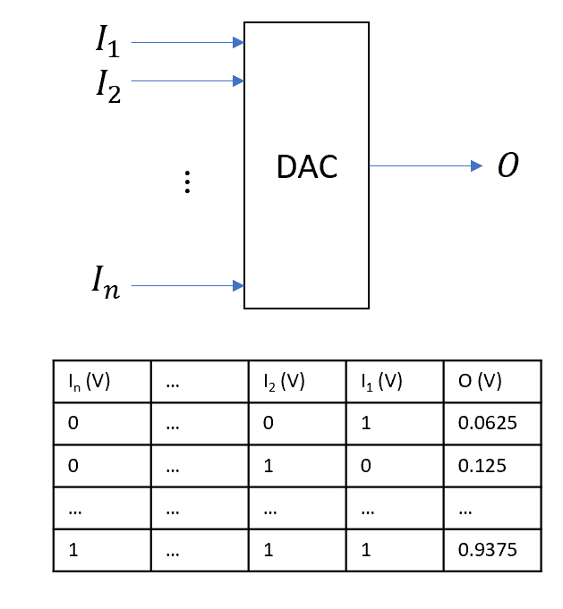
Analog to Digital Converter
In this course, analog to digital conversion means the conversion of a periodic waveform like a sine wave into a DC value.
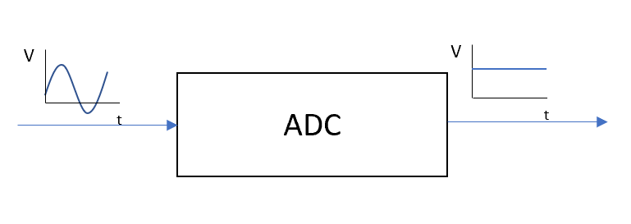
Digital to Analog Converter MS3
In MS3, a digital to analog converter means the conversion of a DC value into a sinusoidal AC signal. This can be done in many different ways! Make sure you discuss with your TA if the DAC circuit you plan to use is appropriate and aligns with the course concepts.

The Proof of Concepts, Project Manual, and Presentation grades must be at least 80%. The Project Plan must be submitted for every milestone.
Do NOT use transistors to implement this circuit. Use an Op Amp or 555 Timer.
Two sequential first-order filters to form a second-order filter counts ONLY as a second-order filter building block.
If your circuit has a T-Line

